Chapter 9, Solution 36.

Using Fig. 9.43, design a problem to help other students to better understand impedance.

Although there are many ways to work this problem, this is an example based on the same kind of problem asked in the third edition.

Problem

In the circuit in Fig. 9.43, determine i. Let v_{s} = 60 cos(200t - 10°) V.

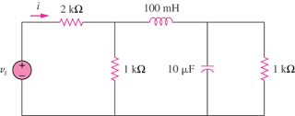

Figure 9.43

Solution

Let Z be the input impedance at the source.

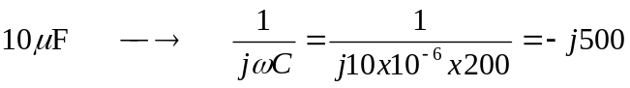

1000//-j500 = 200 –j400
1000//(j20 + 200 –j400) = 242.62 –j239.84

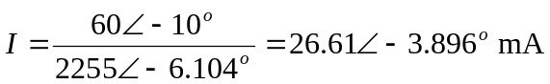

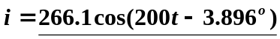mA

